# CS 255 System Design Document Template

## UML Diagrams

### UML Use Case Diagram

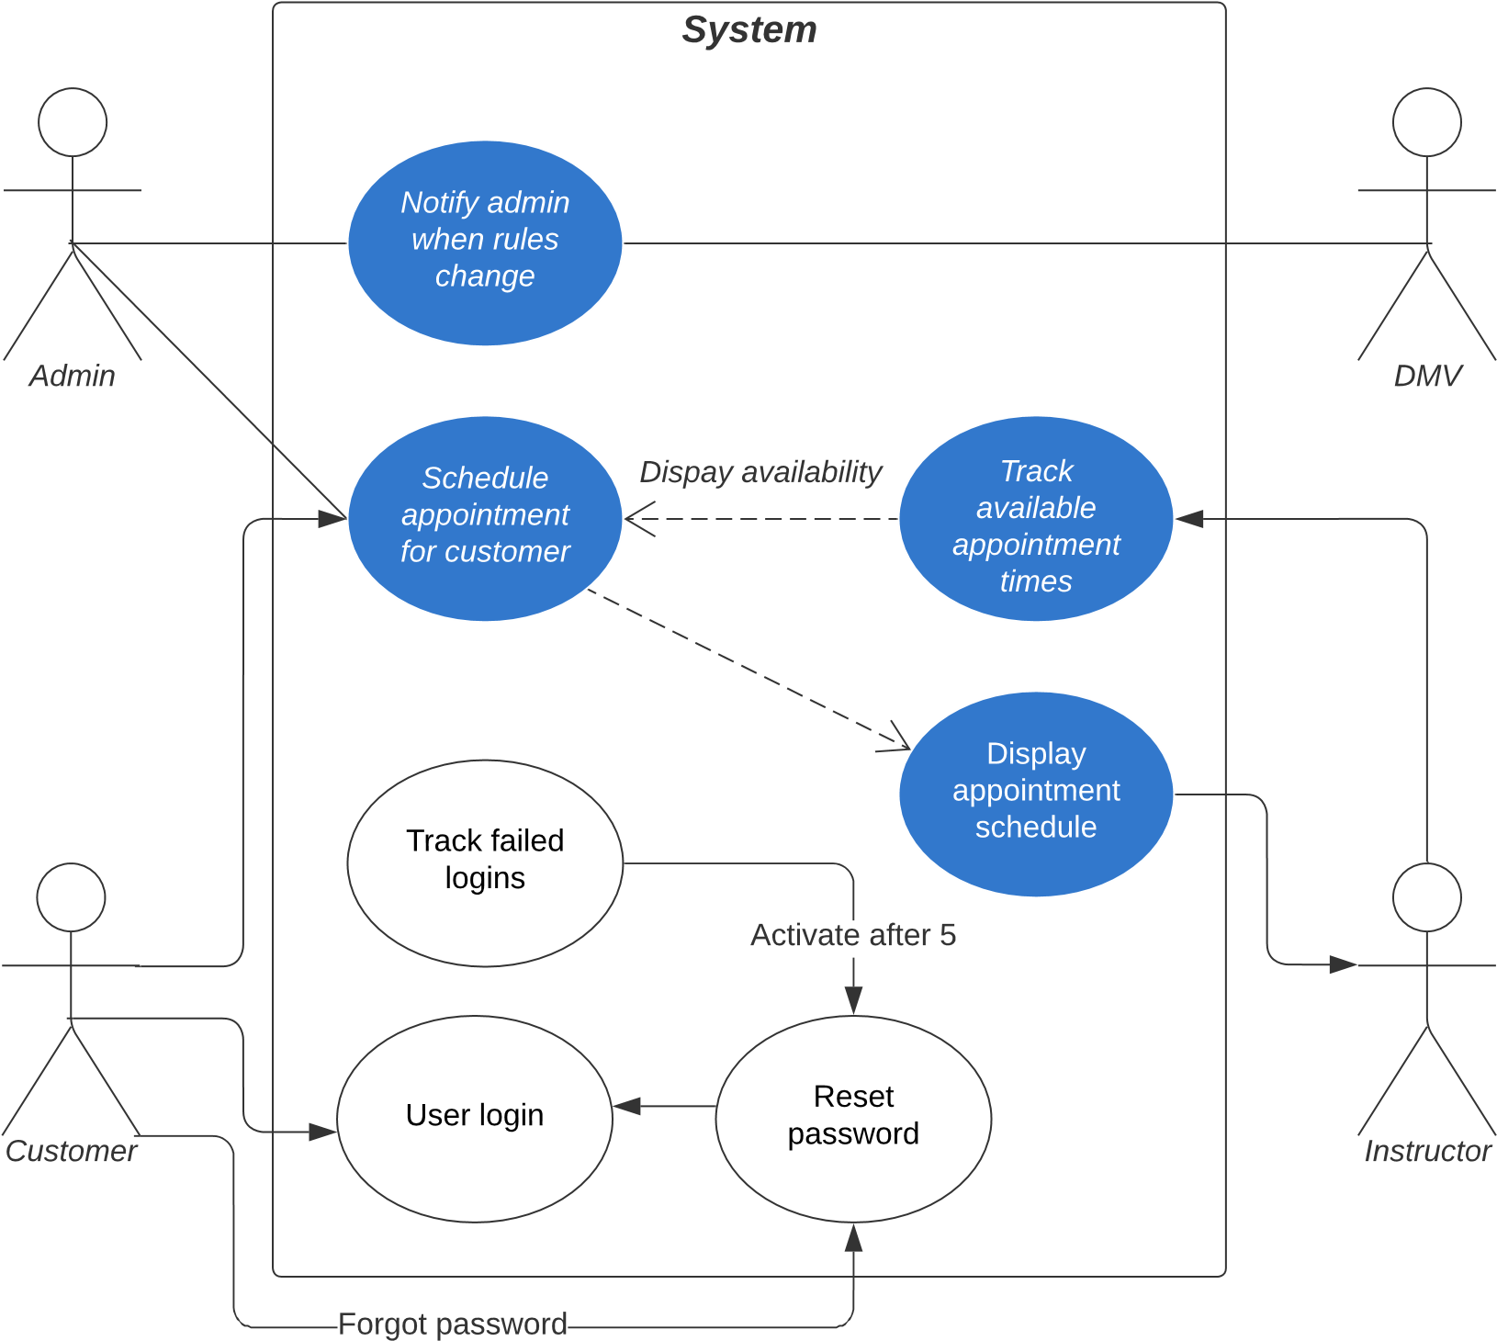

### UML Activity Diagrams

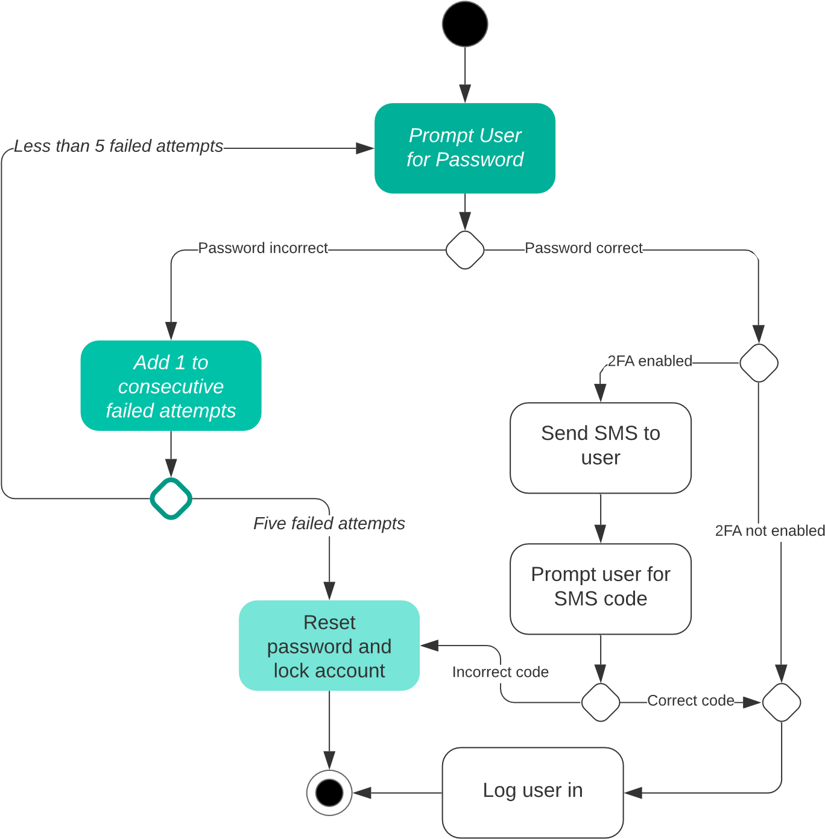

### UML Sequence Diagram

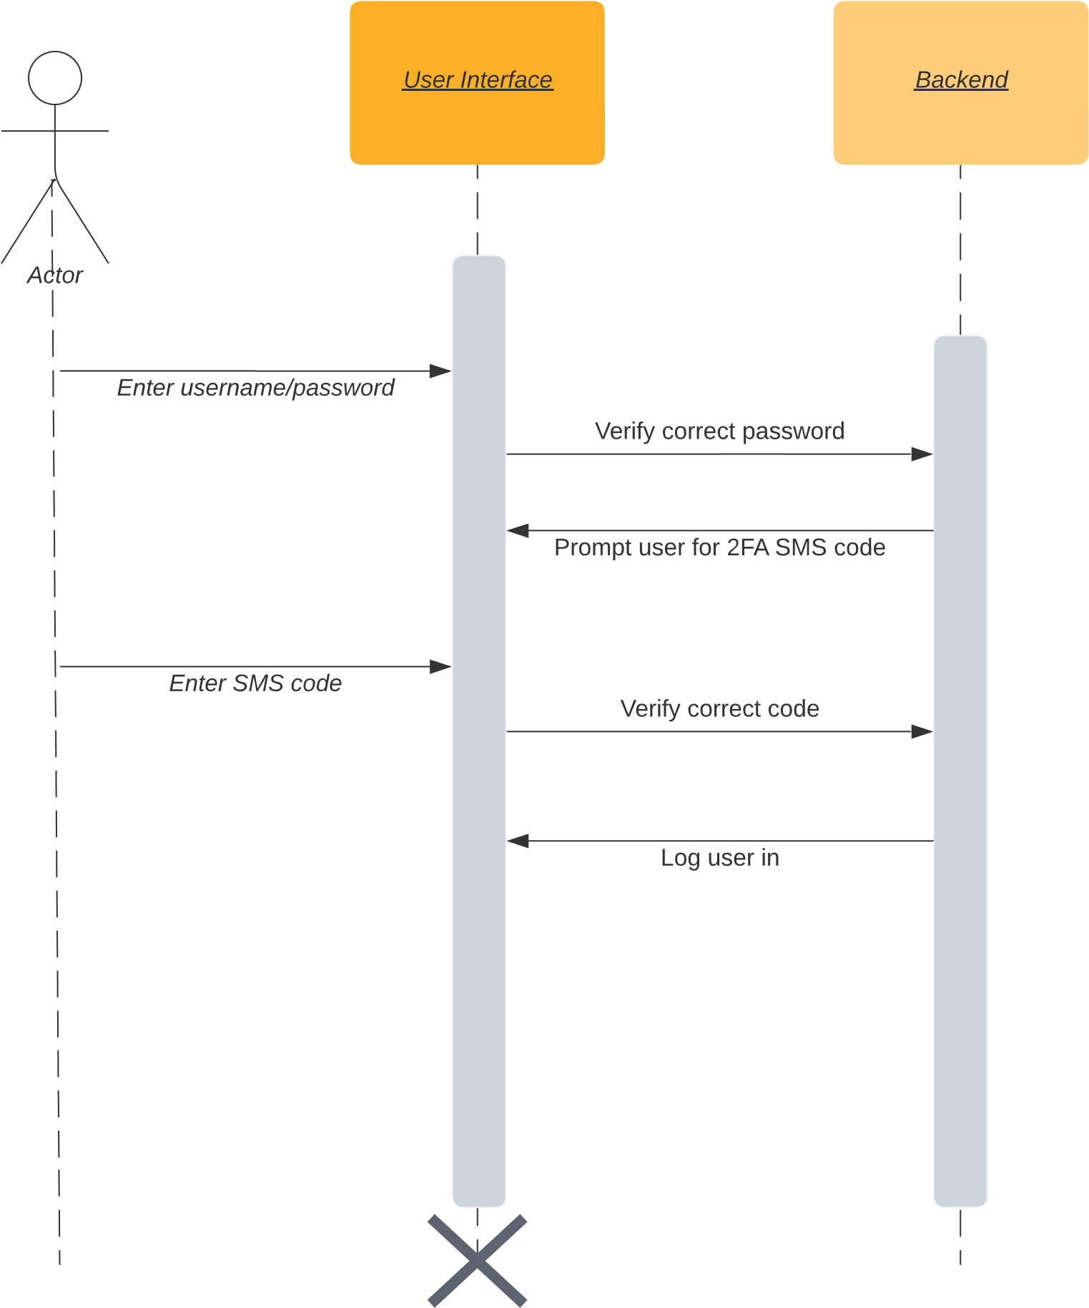

### UML Class Diagram

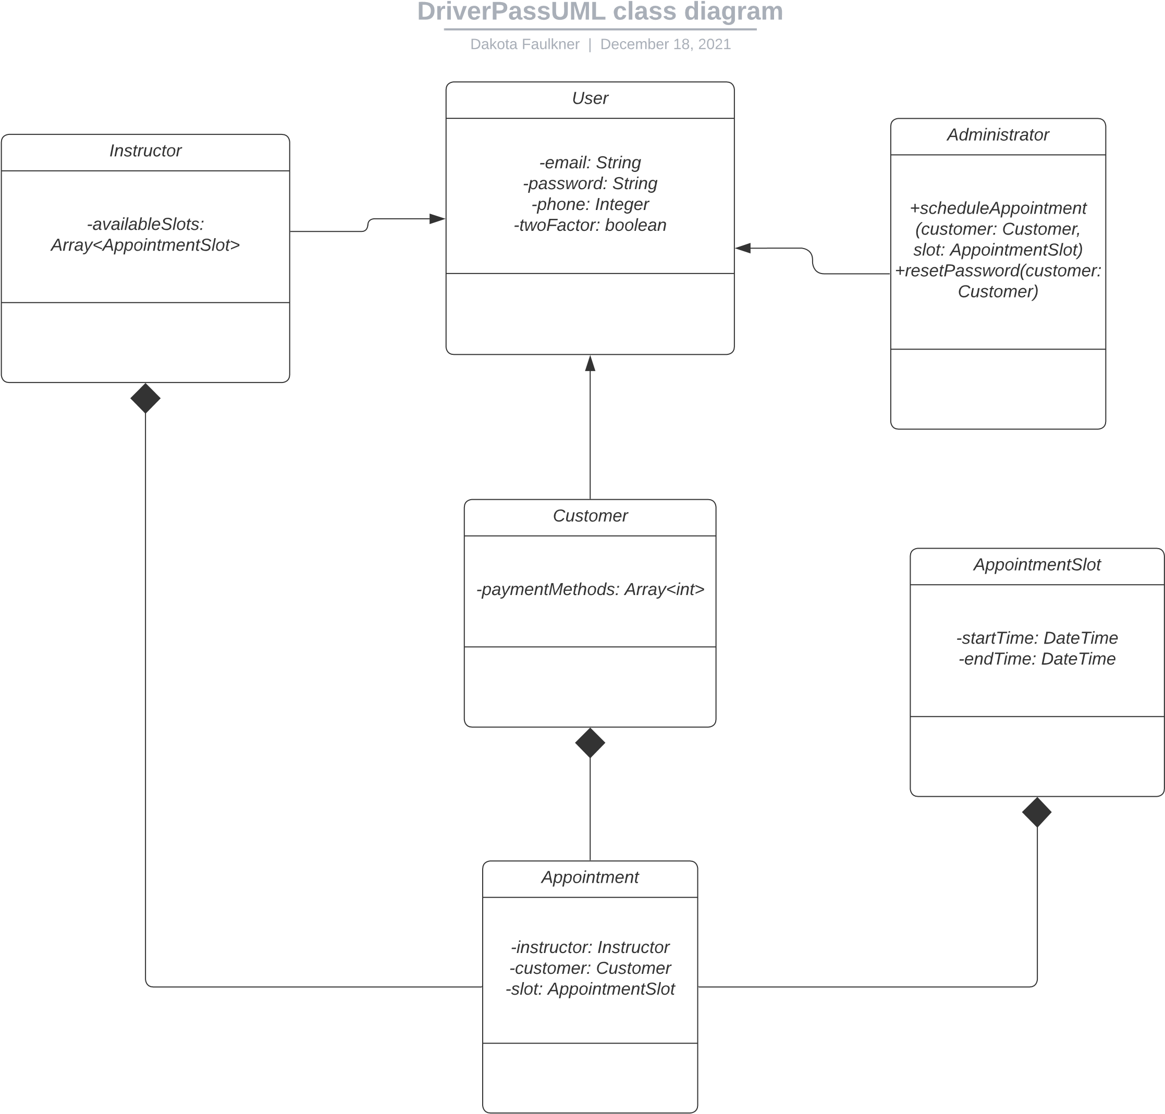

## Technical Requirements

* A host system for running the backend database and web interface
* Payment processing service (in-house or third party)
* It would be very important to have stable and reliable internet to ensure smooth and uninterrupted functionality.
* Desktop computer to access web interface from administrative offices.